EUROPEAN COMMISSION
DIRECTORATE-GENERAL FOR MOBILITY AND TRANSPORT

Directorate C - Land
C.1 - Road Transport

Questions and Answers
on posting of drivers under Directive (EU) 2020/1057
in the context of transport of goods

DISCLAIMER: This guide was prepared by the Commission services and does not commit the European Commission. Only the Court of Justice of the European Union is competent to authoritatively interpret Union law.

GENERAL CRITERIA
determining when a driver is posted or not under Directive (EU) 2020/1057
Directive (EU) 2020/1057 (also referred to as “the Directive”) lays down specific rules with respect to Directive 96/71/EC and to Directive 2014/67/EU, both of which are legislative acts concerning the posting of workers in the framework of the provision of services. It distinguishes between types of transport operations to which rules on posting should apply and those to which posting rules should not apply. The general criterion for such distinction is the degree of connection with the territory of the host Member State.

More specifically, it results from Directive (EU) 2020/1057 that drivers carrying out transport operations in Member States other than the Member State where the employer of the driver has its establishment are posted when performing the following operations:

- cross-trade operations – understood as transport operations carried out between two Member States, or between a Member State and a third country, none of which is the country of establishment of the operator carrying out these operations;
- cabotage operations – understood as domestic transport operations for hire or reward carried out on a temporary basis on the territory of a Member State by an operator established in another Member State.

The driver shall not be considered to be posted when performing:

  - international bilateral transport operations – understood as transport operations based on a transport contract from the Member State where the operator is established (Member State of establishment) to another Member State or to a third country, or from another Member State or a third country to the Member State of establishment;
  - limited additional activities of loading and/or unloading (that is, cross-trade operations as described above) carried out in the context of bilateral operations in the Member States or third countries that the driver crosses;
  - transit through the territory of a Member State without carrying out any activity of loading or unloading;
  - initial or final leg of a combined transport operation, as defined in Council Directive 92/106/EEC, in case the road leg on its own consists of an international bilateral transport operation.

ADMINISTRATIVE OBLIGATIONS
of the operator before, during and after the posting

Directive (EU) 2020/1057, in its Article 1, paragraphs 11 and 12, specifies the administrative requirements that operators must fulfil to prove compliance with the rules on posting of drivers.

Prior to the posting the operator shall:
- submit a posting declaration to the authorities of a Member State to which the driver is posted;
- at the latest at the commencement of the posting;
- using the multilingual public interface connected to the Internal Market Information (IMI) system;

The content of the posting declaration:
- the identity of the operator, at least in the form of the number of the Community licence where this number is available;
- the contact details of a transport manager or other contact person in the Member State of establishment to liaise with the competent authorities of the host Member State in which the services are provided and to send out and receive documents or notices;
- the identity of the driver, the address of the residence and the number of his/her driving licence;
- the start date of the driver's contract of employment, and the law applicable to it;
- the envisaged start and end date of the posting;
- the number plates of the motor vehicles;
- the transport services performed (e.g. carriage of goods, carriage of passengers, international carriage or cabotage operations).

During the posting the operator shall:
- ensure that the drivers have at their disposal the following documents:
- the posting declaration in paper or electronic form;
- evidence of the transport operations taking place in the host Member State, such as an electronic consignment note (e-CMR)
- the tachograph records (in particular country symbols of the Member States in which the driver carried out transport operations).

After the posting the operator shall:
- no later than eight weeks from receiving the request of the host Member State, send via the public interface connected to IMI the requested documents, such as:
- tachographs records;
- consignment notes;
- documentation relating to the remuneration of the driver in respect of the period of posting;
- the employment contract;
- time-sheets relating to the driver's work;
- proof of payments of driver’s remuneration.

Member States’ authorities may not impose any additional administrative requirements on the operators than those specified in the Directive, in order to check compliance with its provisions.

TRANSPORT OPERATION SCENARIOS

The following sections explain and illustrate how the posting rules apply in different transport operation scenarios:

- BILATERAL
- CROSS-TRADE
- CABOTAGE
- TRANSIT
- UNLADEN JOURNEYS

Legend:
Start of transport and loading
Unloading and end of transport
Loading of the first additional operation
Unloading of the first additional operation
Loading of the second additional operation
Unloading of the second additional operation
Bilateral operation
Additional exempt transport operation
Non-exempt transport operation
Transit / Unladen journey

- BILATERAL

- What are international bilateral transport operations exempt from posting rules?

Scenario 1: Two bilateral operations
A driver employed by a company established in Lithuania (LT) drives a full truck of goods from Vilnius (LT) to Paris (FR). The driver unloads all goods in Paris. Then, for the return journey, the driver loads goods in Paris to deliver them to Vilnius (LT).

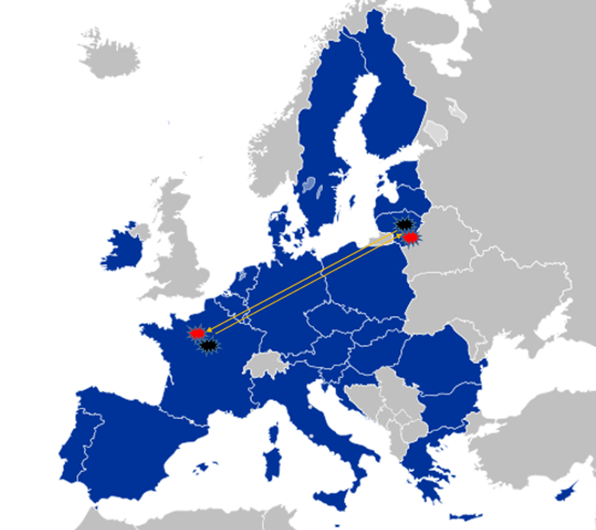
Conclusion: The driver performed two bilateral transport operations: one from LT (Member State of establishment) to FR (host country) and another one from FR back to LT. Hence, the driver was not subject to posting rules during the entire journey.

Scenario 2: bilateral operations with three unloading locations
A driver employed by a company established in Lithuania (LT) loads a full truck of goods in Vilnius (LT). The driver then drives to Berlin (DE) and unloads 1/3 of the goods, and then to Antwerp (BE) to unload another 1/3 of goods. Afterwards, the driver continues to drive to Lyon (FR), and unloads the remaining 1/3 of the goods.
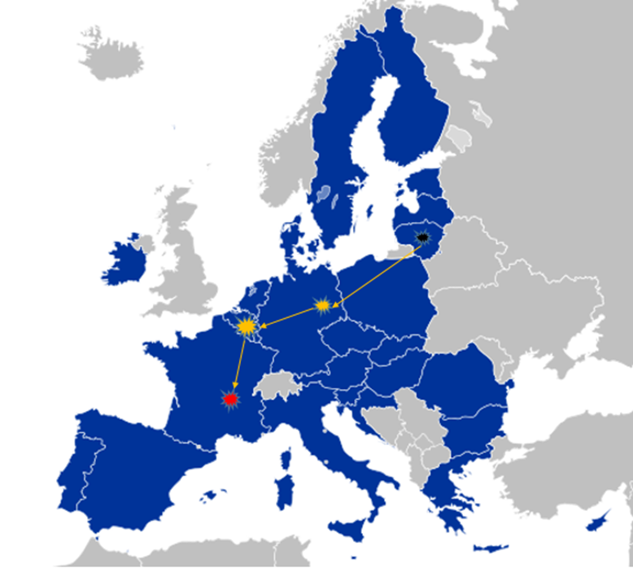

Conclusion: The driver performed 3 bilateral operations within one journey. The journey started with loading the truck full of goods in LT (Member State of establishment) which have then been unloaded in 3 different countries (partial unloading of goods in DE, BE, FR). Since several exempt bilateral transport operations (i.e. each covered by a separate consignment note) may be carried out during one journey, the driver was not subject to posting rules for the entire journey.

Scenario 3: bilateral operations with three loading locations
After carrying out the operations described in Scenario 2, on the way back to LT, the driver employed by the company established in Lithuania (LT) loads a 1/3 truck with goods in Lyon (FR). The driver then drives to Brussels (BE) and loads another 1/3 truck with goods, and then to Warsaw (PL) to load the remaining 1/3 truck with goods. Afterwards, the driver continues to drive to Vilnius (LT), to unload all the goods.

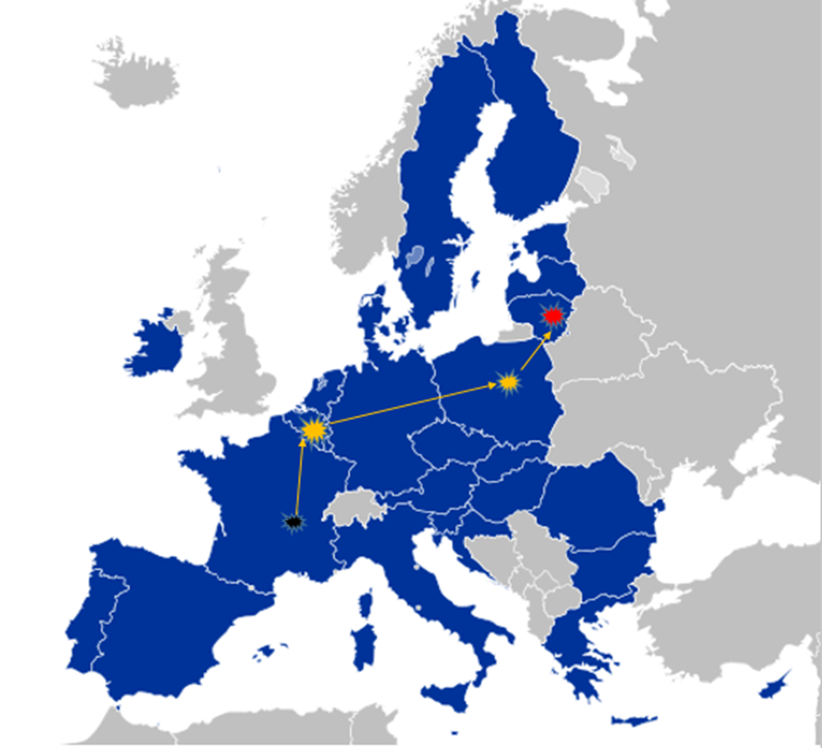

Conclusion: The driver performed 3 bilateral operations during one return journey to the Member State of establishment. Since several exempt bilateral transport operations (i.e. each under separate consignment note) may be carried out during one journey, the driver was not subject to posting rules for the entire journey.

- CROSS-TRADE

- Are the drivers carrying out cross-trade operations subject to the rules on posting of drivers?
Scenario 4: cross-trade between two bilateral operations
A driver employed by a company established in Portugal (PT) carries a full truck of goods from Lisbon (PT) to Marseille (FR). The driver unloads the goods in Marseille. In Marseille (FR), the driver then loads a full truck of goods and unloads them in Berlin (DE). In Berlin, the driver loads a full truck of goods and unloads them in Porto (PT).

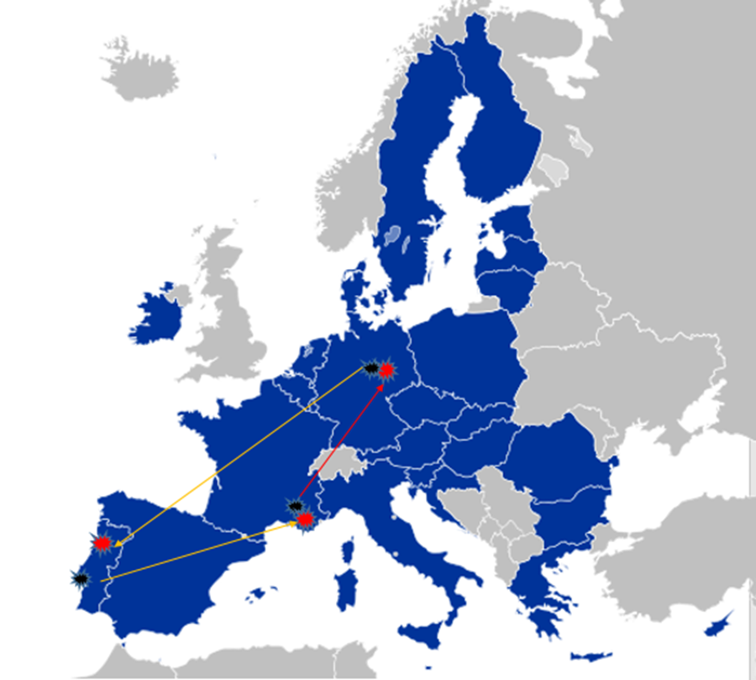

Conclusion: The driver performed two distinct bilateral operations and one cross-trade operation. The first bilateral operation started in PT (Member State of establishment) with loading goods and ended in FR with unloading those goods. The second bilateral operation was performed from loading the goods in DE to unloading them in PT (Member State of establishment). During the two bilateral operations, the driver was not subject to posting rules. The operation of loading goods in FR and unloading them in DE was a cross-trade operation not connected to any of the two bilateral operations. Therefore, the driver starts to be posted to FR after the end of bilateral operation when he/she starts driving to the loading point to load the goods to be carried in the context of cross-trade operation. The posting to FR ends when the driver leaves the French territory. Then the driver is considered posted to DE, from the entry into DE territory until unloading goods in that Member State.
Scenario 5: cross-trade between a bilateral operation and an unladen journey
A driver employed by a company established in Portugal (PT) loads a truck full of goods in Lisbon (PT) and drives to Berlin (DE), where these goods are unloaded. In Berlin (DE), the driver loads a full truck of other goods and unloads them in Madrid (ES). Then, the driver drives empty from Madrid (ES) back to his/her Member State of establishment (PT).

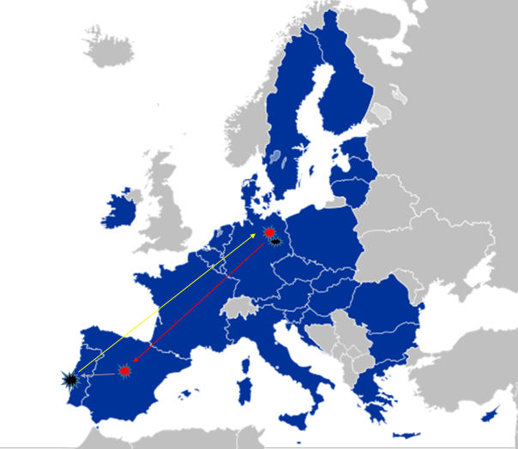

Conclusion: The driver performed one bilateral transport operation from PT to DE, one cross-trade operation from DE to ES and one unladen return journey from ES back to PT.. The driver starts being posted to DE after the end of bilateral operation when he/she starts driving to the loading point to load the goods to be carried in the context of cross-trade operation from DE to ES. The posting to DE ends when the driver leaves the DE territory. Then the driver is considered posted to ES from the moment of entering ES territory until the goods brought from DE within cross-trade operation have been unloaded and the driver finished the cross-trade operation. The unladen return journey through the territory of ES is not considered posting. The driver is not considered posted in FR which he/she transits during the bilateral journey from PT to DE and during cross-trade operation from DE to ES.

- What are limited additional activities of loading and/or unloading exempt from posting rules?
The driver is exempt from posting rules where, in the context of an ongoing bilateral transport operation, he/she also performs one “cross-trade” activity of loading and/or unloading in the Member State or third country that the driver crosses, provided that the driver does not load goods and unload them in the same Member State.

This is possible, for example, when the driver performs bilateral operation without a full truckload, and in order to use the vehicle loading capacity to the maximum, the driver loads additional goods along the way. The driver may perform one exempt cross-trade operation (that is, an additional loading and/or unloading activity) during a bilateral operation from the Member State of establishment to the host Member State. When two consecutive bilateral operations are carried from and to the Member State of establishment, during each of the two operations an exempt additional cross-trade operation may be peformed. This is a so called 1+1 rule.

Scenario 6: two bilateral operations with two cross-trades (1+1)
A driver employed by a company established in Lithuania (LT) loads ½ a truck with goods in Vilnius (LT) to be delivered to Barcelona (ES). The driver stops in Berlin (DE) and loads the remaining ½ a truck with different goods. The driver then goes to Brussels (BE) and unloads those goods loaded in Berlin (DE). Afterwards, the driver continues the journey and unloads in Barcelona (ES) the goods loaded in Vilnius (LT). For the return bilateral operation, the driver loads a full truck of goods in Barcelona (ES). The driver stops in Brussels to unload ½ of the goods. The driver then continues to Vilnius (LT) to unload the remaining ½ of the goods.

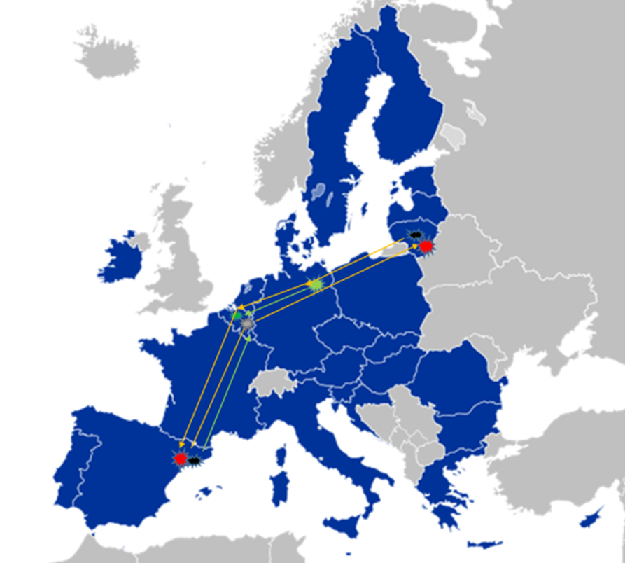
Conclusion: The driver performed two bilateral transport operations with one additional activity of loading and/or unloading (cross-trade) during each bilateral operation. The first bilateral operation was performed from LT to ES, with one exempt additional activity (i.e. loading goods in DE and unloading them in BE). The second (return) bilateral operation was performed from ES to LT, also with one exempt additional activity (i.e. loading goods in ES and unloading part of it in BE). The driver was not subject to posting rules for the entire journey.

It is to be noted that one single exempted additional activity may include:
- a loading action;
- an unloading action; or
- a loading and unloading action
as specified in Article 1.3 of Directive (EU) 2020/1057.

- Is it possible for the driver to undertake two exempt additional activities during a return bilateral transport operation to the Member State of establishment, if no additional activity was performed during the bilateral operation from Member State of establishment?
Yes, when the driver has not used the possibility of performing one exempt additional activity of loading and/or unloading (cross-trade) during the bilateral transport operation from the Member State of establishment, and this operation is followed by a return bilateral operation to the Member State of establishment, two exempt additional activities of loading and/or unloading (cross-trade) may be performed during that return bilateral operation. This is a so called 0+2 rule.

Scenario 7: one bilateral operation with two cross-trades (0+2)
A driver employed by a company established in Lithuania (LT) loads a full truck with goods in Vilnius (LT) and delivers them in Madrid (ES).
The driver then loads a full truck of goods in Madrid (ES). The driver stops in Brussels (BE) to unload ¼ of those goods. The driver then drives to Berlin (DE) and unloads ¼ of the goods. The driver then continues to Vilnius (LT) to unload the remaining ½ of the goods.

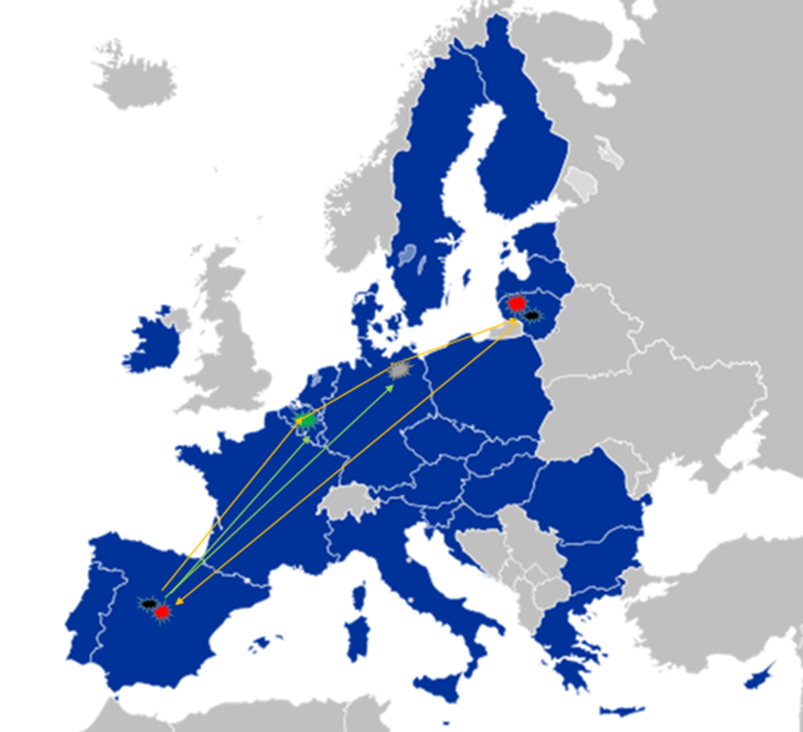

Conclusion: The driver performed two bilateral transport operations with two additional activities of unloading (cross-trade) during the return bilateral operation. The first bilateral operation was performed from LT to ES, with no additional activities in between. The second (return) bilateral operation was performed from ES to LT, with two exempt additional activities (i.e. cross-trade operations between ES-BE and ES-DE, consisting in two additional unloading activities). The driver was not subject to posting rules during the entire journey.
Scenario 8: one bilateral operation with two cross-trades (0+2)
A driver employed by a company established in Lithuania (LT) loads a full truck with goods in Vilnius (LT) and delivers them in Barcelona (ES). The driver loads ½ a truck with goods in Barcelona (ES) and then stops in Lyon (FR) and loads ½ a truck with another type of goods. Afterwards, the driver drives to Brussels (BE) and unloads the goods loaded in Lyon (FR). The driver then continues to Berlin (DE) to load ½ a truck with other goods, which are then unloaded in Warsaw (PL). Finally, the driver continues to Vilnius (LT) where he/she unloads the goods loaded in Barcelona (ES).

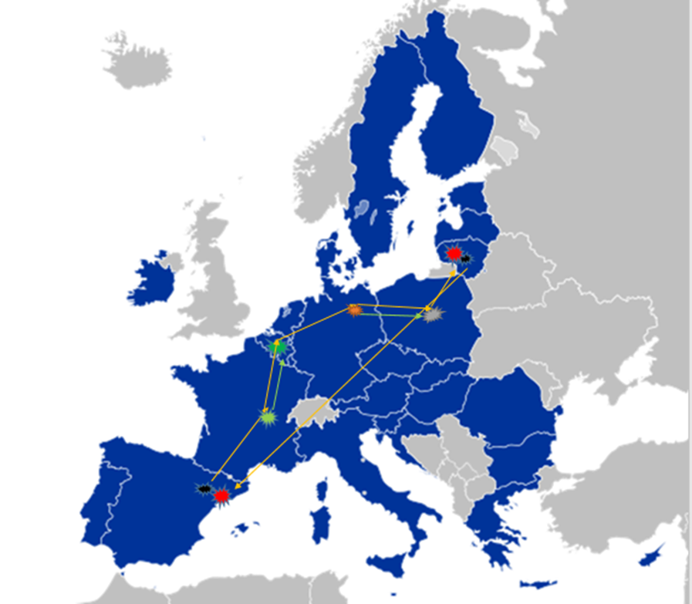

Conclusion: The driver performed two bilateral transport operations with two additional activities, each of them consisting in a loading and unloading activity (cross-trade), during the return bilateral operation. The first bilateral operation was performed from LT to ES, with no additional activity. The second (return) bilateral operation was performed from ES to LT, with two exempt additional activities (i.e. cross-trade operations between FR-BE and DE-PL, both of them consisting in an additional loading and unloading activity). The driver was not subject to posting rules for the entire journey.

- In case of more than one additional activity carried out in the context of a bilateral transport operation, which of those activities is exempt and which is subject to the posting rules?
Where multiple cross-trade operations are carried out in the context of an ongoing bilateral operation, the first activity (in the case of the 1+1 rule) or the first two activities (in the case of the 0+2 rule) are exempted from posting rules. Hence, when the operator carries out a third additional activity (in the 1+1 scenario or in the 0 + 2 scenario), or more, such additional activities are no longer exempt, therefore falling under the posting rules.

Scenario 9: bilateral operation with one exempt cross-trade and one non-exempt cross-trade
A driver employed by a company established in Lithuania (LT) loads ½ a truck with goods in Vilnius (LT), to be delivered to Madrid (ES). While driving to Madrid, the driver stops in Warsaw (PL) to load ½ a truck with other goods to deliver them toBerlin (DE). After unloading the goods from Warsaw in Berlin, the driver then loads ½ a truck with another type of goods in Berlin (DE) and unloads them in Brussels (BE). Afterwards, the driver continues to Madrid (ES), and unloads the goods loaded in Vilnius (LT).
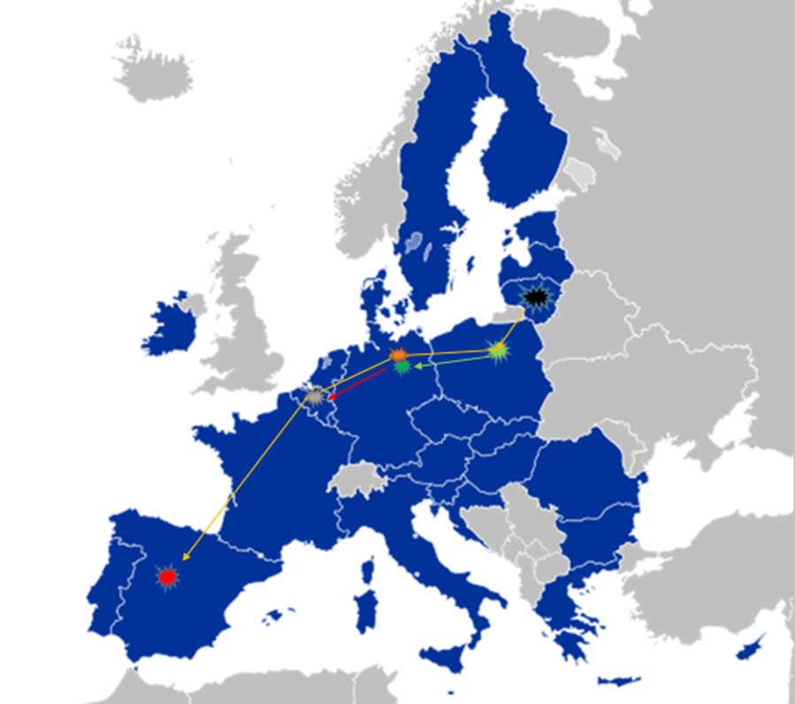
Conclusion: The driver performed one bilateral transport operation (from LT to ES) and two additional activities of loading and unloading (cross-trade operations) during this bilateral operation. The first additional activity of loading goods in PL and unloading them in DE is exempt from posting rules, while the second additional activity of loading goods in DE and unloading them in BE falls within the posting rules. This is due to the fact that the driver has already used the possibility for one exempt additional activity of loading and unloading. The posting situation starts applying with loading goods in Berlin (DE) and it ends when those goods are unloaded in Brussels (BE) – as the driver then resumes the bilateral operation exempted from posting rules. Hence, the driver is considered posted to DE from the moment of loading goods in Berlin and ends when he/she leaves DE territory. Then the driver is considered posted to BE from entry to the BE territory until unloading the goods in Brussels. After unloading the goods in Brussels, the driver resumes the bilateral operation, which is exempt from the posting rules.
- CABOTAGE

Scenario 10: Two bilateral operations + cabotage
A driver employed by a company established in Portugal (PT) loads a full truck with goods in Lisbon (PT) and delivers them in Hamburg (DE).After unloading goods in Hamburg (DE), the driver loads a full truck with other goods and unloads them in Munich (DE). Then in Munich (DE), the driver loads a full truck with goods to be delivered to Lisbon (PT).

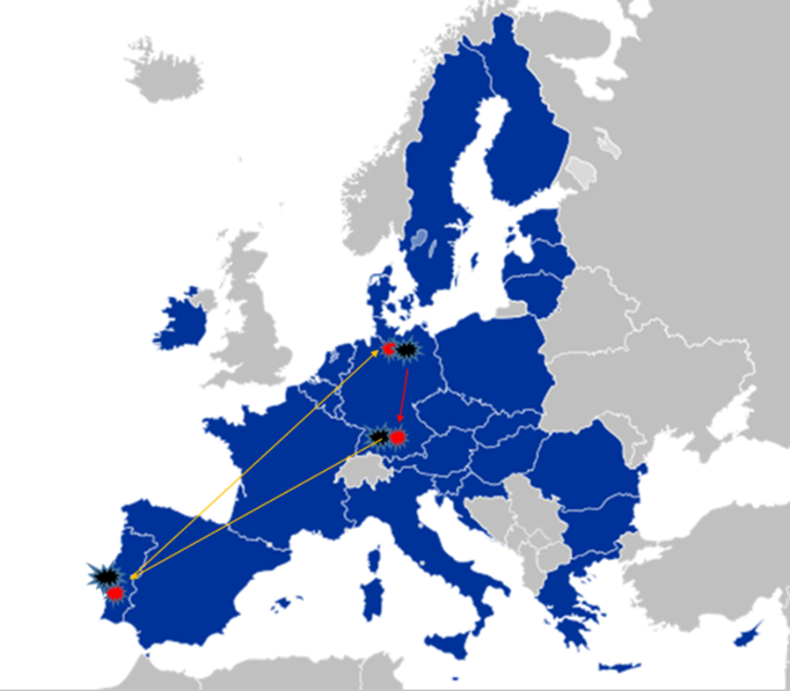

Conclusion: The driver performed two bilateral operations (one from PT to DE and another one from DE back to PT) and one cabotage operation in DE. The driver is considered posted to DE. The posting situation starts after the end of bilateral operation (unloading goods in Hamburg) when he/she starts driving to the loading point to load the goods for the cabotage operation in DE. The posting continues through the carrying out of the cabotage operation and ends when the goods are unloaded and the cabotage operation is finalized. The driver is not considered posted to DE for the part of the journey after the end of the cabotage operation and when he/she starts working for the return bilateral operation (i.e.: drives to the loading point, loads goods for bilateral operation and carries them through the DE territory).

- TRANSIT

- What is ‘transit’ and is it out of the scope of posting rules?
The concept of transit is characterised by the fact that the driver crosses through the territory of a Member State without loading or unloading freight. The qualification of the driver’s presence in a Member State as transit is, therefore, not affected by stops, for example, for hygiene reasons, refuelling, taking breaks or rest periods. This means that a transit situation is out of the scope of posting rules.

Scenario 11: transit + bilateral operation + cross-trade + transit
A driver employed by a company established in Portugal (PT) loads a truck full of goods in Lisbon (PT) to be delivered to Madrid (ES). In Madrid (ES) the driver loads a truck full of goods to be delivered to Dortmund (DE). After delivery in Dortmund, the driver returns with the empty truck to Lisbon (PT).

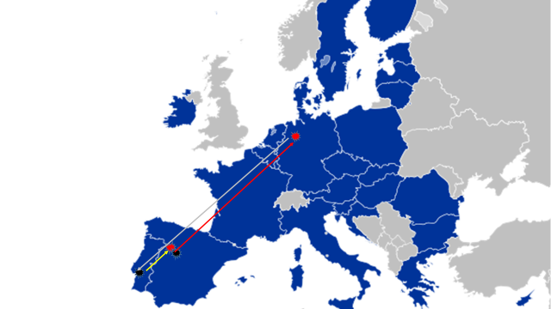

Conclusion: The driver performed one bilateral operation from PT to ES, one cross-trade operation from ES to DE and one unladen journey from DE back to PT. The driver is not considered posted to ES for the part of the journey performed under bilateral operation. The driver starts being posted to ES after the end of bilateral operation (unloading goods in Madrid) and when he/she starts driving to the loading point to load the goods for cross-trade operation from ES to DE. The posting to ES ends when the driver leaves ES territory. Then the driver is considered posted to DE from the moment of entering DE territory until leaving the end of cross trade operation in DE.. The driver is not considered posted to DE during the unladen journey returning to PT, after the end of cross-trade operation. The driver is not considered posted either in FR or in BE, because he/she only transits through the territories of these countries when performing cross-trade operation.

- UNLADEN JOURNEYS

- Is an unladen journey the same as ‘transit’?
No. A transit situation is always exempt from posting rules, while an unladen journey is exempt if it is carried out in connection with a bilateral operation and is not exempt when it is carried out in connection with cabotage or non-bilateral international operation falling under posting rules (cross-trade).

In principle, posting ends with unloading goods carried within the operation falling under posting rules (e.g. cabotage or cross-trade). The classification of the subsequent unladen journey as posting or as exempt from posting depends on whether the new operation, which actuates that unladen journey, is covered by posting rules or not. In this context, it is important to note, that the driver is not considered posted if, after unloading the goods within the operation covered by posting rules, he/she performs an unladen journey back to his/her MS of establishment.
Scenario 12: bilateral operation + unladen journey
A driver employed by a company established in Lithuania (LT) loads a full truck of goods in Vilnius (LT) and unloads them in Paris (FR). On the way back, the driver drives empty from France (FR) to Lithuania (LT).

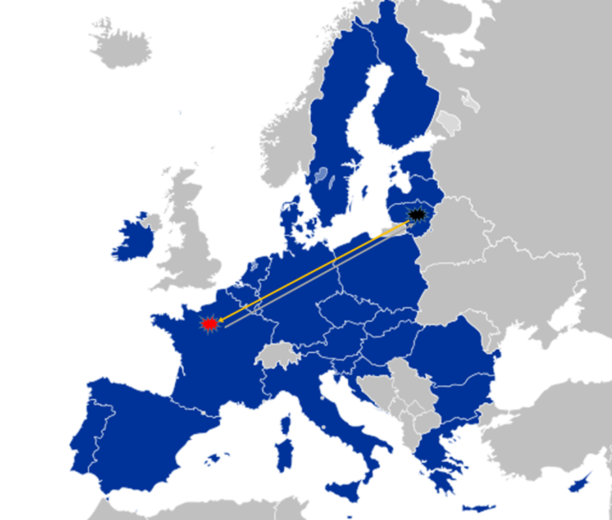
Conclusion: The driver performed one bilateral transport operation from LT to FR, followed by an unladen journey from FR back to LT. The driver is not considered posted for the entire journey: neither during the bilateral operation to FR nor during the unladen journey performed after the end of bilateral operation from the Member State of establishment in order to return to that Member State.

Scenario 13: Two bilateral operations + one unladen journey
A driver employed by a company established in Lithuania (LT) loads goods in Vilnius (LT) and unloads them in Paris (FR). The driver drives with an empty truck from Paris (FR) to Antwerp (BE). The driver then loads goods in Antwerp (BE) and unloads them in Vilnius (LT).

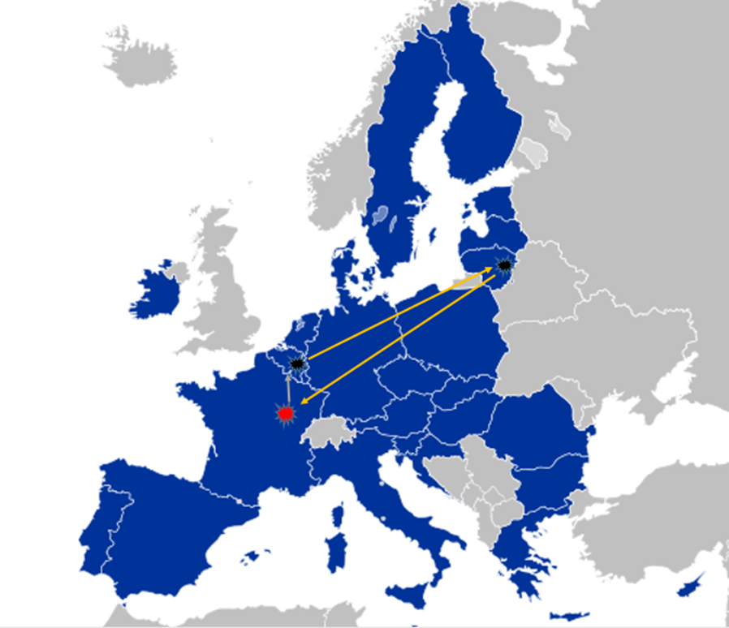

Conclusion: The driver performed two bilateral transport operations and one unladen journey between them. The first bilateral operation occurred from LT to FR, while the second bilateral operation was carried out from BE to LT. The unladen journey between FR and BE should be considered as carried out in conjunction with the second bilateral transport operation starting in BE, therefore meaning that posting rules do not apply. Hence, the driver is not to be considered as posted during all of these operations.

Scenario 14: two unladen journeys + one cross-trade
A driver whose company is based in Poland (PL) carries out an unladen journey from Warsaw (PL) to Berlin (DE). In Berlin (DE), the driver loads a full truck of goods and unloads them in Brussels (BE). Then, the driver drives empty from Brussels (BE) to Warsaw (PL).

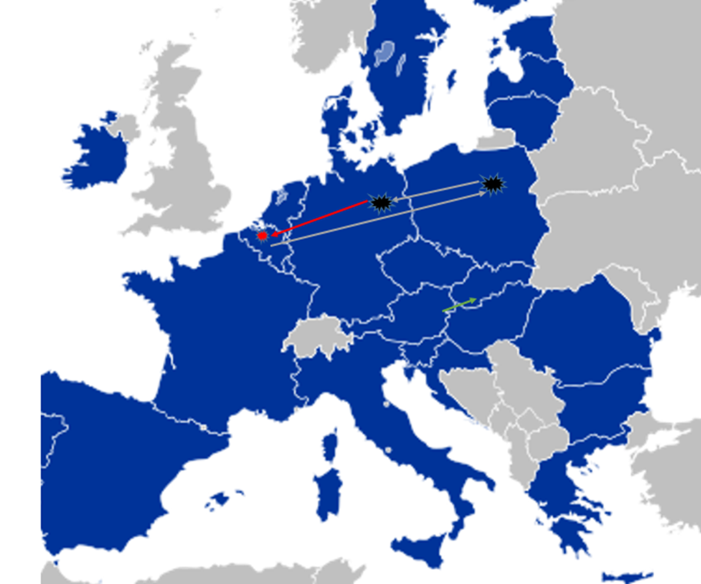

Conclusion: The driver performed two distinct unladen journeys and one cross-trade operation between them. The first unladen journey between PL and DE was followed by a cross-trade operation between DE and BE, which was then followed by an unladen journey from BE back to PL. The unladen journey from PL to DE is carried out in conjunction with the cross-trade operation starting in DE. Therefore, the driver is considered posted to DE from the moment of entering DE territory until leaving the DE territory. This period covers driving with an empty truck to the loading point in DE, loading goods in DE and carrying them through DE territory. Then the driver is considered posted to BE from the moment of entering the BE territory until the end of cross-trade operation in BE. The driver is not considered posted to BE during unladen journey after the end of cross-trade operation when returning to the Member State of establishment. The driver is not considered posted to NL when performing cross-trade operation between DE and BE because he/she only transits the NL territory without loading or unloading.

Scenario 15: two bilateral operations + cabotage + two unladen journeys
A driver employed by a company established in Germany (DE) loads a truck full of goods in Berlin (DE), drives to Paris (FR) and unloads all the goods. The driver then drives empty to Lyon (FR) to load goods and unloads them in Marseille (FR). The driver then drives empty from Marseille (FR) to Nantes (FR). On the way back to Germany (DE), the driver loads a truck full of goods in Nantes (FR) and unloads them in Berlin (DE).

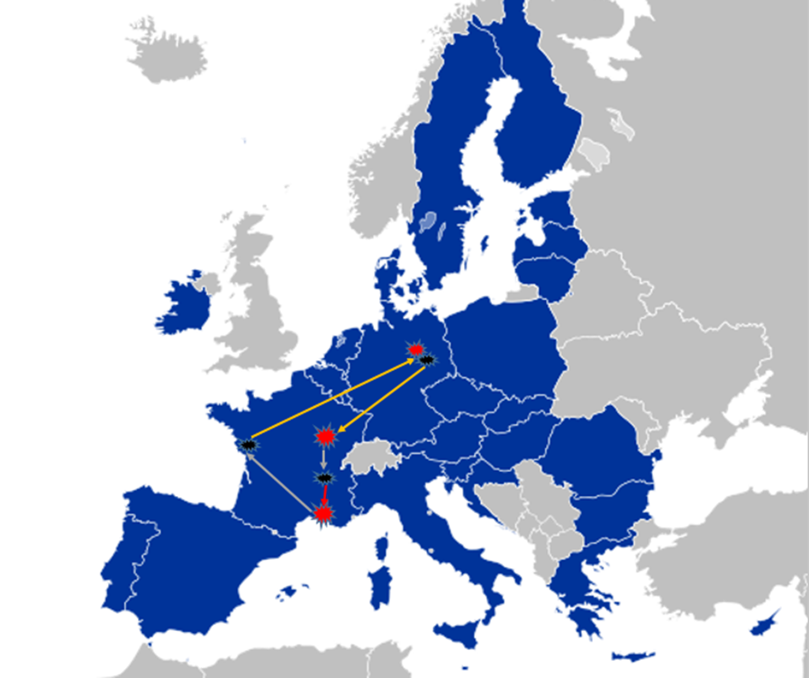

Conclusion: The driver performed two bilateral transport operations (from DE to FR and from FR to DE), one cabotage operation in FR, and two unladen journeys in FR. The first bilateral operation from DE ended with unloading goods in Paris (FR). The driver starts being posted in FR after the end of that bilateral operation when he/she starts driving (unladen journey) to the loading point where he/she loads goods to be carried under cabotage operation in FR. The posting to FR ends when the cabotage operation is finished, as after that the driver drives with an empty truck to load goods which are to be delivered within bilateral operation from FR to DE. Hence, first unladen journey between Paris and Lyon falls within the posting rules, as this journey is connected to the cabotage operation performed between Lyon and Marseille. The second unladen journey between Marseille and Nantes is exempt from the posting rules, as this journey is connected with the return bilateral operation from Nantes (FR) to Berlin (DE), which is exempt from posting rules.

This guide refers only to questions and answers on posting of drivers in the context of carriage of goods by road. A different set of questions and answers will be prepared on the same topic, as regards the rules on the carriage of passengers.
Directive (EU) 2020/1057 of the European Parliament and of the Council of 15 July 2020 laying down specific rules with respect to Directive 96/71/EC and Directive 2014/67/EU for posting drivers in the road transport sector and amending Directive 2006/22/EC as regards enforcement requirements and Regulation (EU) No 1024/2012 (OJ L 249, 31.7.2020, p. 49)
Directive 96/71/EC of the European Parliament and of the Council of 16 December 1996 concerning the posting of workers in the framework of the provision of services (OJ L 18, 21.1.1997, p. 1).
Directive 2014/67/EU of the European Parliament and of the Council of 15 May 2014 on the enforcement of Directive 96/71/EC concerning the posting of workers in the framework of the provision of services and amending Regulation (EU) No 1024/2012 on administrative cooperation through the Internal Market Information System (OJ L 159, 28.5.2014, p. 11).
Recital 9 of Directive (EU) 2020/1057: “Balanced sector specific rules on posting should be based on the existence of a sufficient link between the driver and the service provided, and the territory of a host Member State. To facilitate enforcement of those rules a distinction should be made between different types of transport operations depending on the degree of connection with the territory of the host Member State.”
Referred to in recitals 12 and 13 of the Directive as ‘non-bilateral international transport operations’.
The Member State of establishment is defined in Article 2(8) of Regulation (EC) No 1071/2009.
The cabotage operations in respect of the transport of goods are defined in the Directive with reference to Regulation (EC) No 1072/2009 of the European Parliament and of the Council of 21 October 2009 on common rules for access to the international road haulage market (OJ L 300, 14.11.2009, p. 72).
Recital (10) and Article 1, paragraphs 3 and 4 of Directive (EU) 2020/1057;
Article 1, paragraph 3, third subparagraph of Directive (EU) 2020/1057;
Recital (11) and Article 1, paragraph 5 of Directive (EU) 2020/1057;
Recital (12) and Article 1, paragraph 6 of Directive (EU) 2020/1057;
Council Directive 92/106/EEC of 7 December 1992 on the establishment of common rules for certain types of combined transport of goods between Member States (OJ L 368, 17.12.1992, p. 38).
Recital 10 of Directive (EU) 2020/1057: “When a driver engages in bilateral transport operations from the Member State where the undertaking is established (the ‘Member State of establishment’) to the territory of another Member State or a third country or back to the Member State of establishment, the nature of the service is closely linked with the Member State of establishment. It is possible that a driver undertakes several bilateral transport operations during one journey.”
Recital 11 of Directive (EU) 2020/1057
Article 2.2 of Regulation (EC) No 1072/2009 stipulates that: ‘international carriage’ means: (a) a laden journey undertaken by a vehicle the point of departure and the point of arrival of which are in two different Member States, with or without transit through one or more Member States or third countries; (b) a laden journey undertaken by a vehicle from a Member State to a third country or vice versa, with or without transit through one or more Member States or third countries; (c) a laden journey undertaken by a vehicle between third countries, with transit through the territory of one or more Member States; or (d) an unladen journey in conjunction with the carriage referred to in points (a), (b) and (c);

